*enter 1 x*



**DOI:** <https://doi.org/10.38035/sijse>

<https://creativecommons.org/licenses/by/4.0/>*(size 10)*

*enter 1 x*

**Title: Font Times New Roman, Size 16, Capital Each Word, Left Align, bolds**

*enter 1 x*  
*enter 1 x*

**Author1, Author2, Author3, etc.** *(full name, not abbreviated, without a title, size 12)*

1Institutions, Regions, Countries, email. *(size 11*)

2Institutions, Regions, Countries, email.

3Institutions, Regions, Countries, email.

*enter 1 x*

Corresponding Author: email1

*enter 1 x*

***Abstract:*** *Abstracts are written in one paragraph using standard Indonesian with enhanced spelling. Maximum 200 words, using Times New Roman font size 12, space 1, Italic. Contains a brief description of the overall results of the study including background issues, objectives, methods, results and conclusions. Avoid writing bibliography citations, as well as abbreviations in the abstract. The abstract contains the* ***title*** *of the article, research* ***object****,* ***objectives****,* ***methods*** *and* ***results****. Abstracts written in Bahasa and English (time new roman, size 12, space 1)*

*enter 1 x*

***Keyword:*** *Consists of 3-5 keywords, keyword 1, keyword 2, etc.*

*enter 1 x*

*enter 1 x*

# INTRODUCTION

The introduction contains a concise, concise, and clear research background; research objectives; and supporting theories. Written using Times New Roman font, size 12, space 1. Foreign language writing is typed in italics. Narrative writing, no special sub-title is needed. Including the writing of operational definitions, if deemed necessary, also written in narrative. All forms of reference used must be written down the source. Writing citations or references using body notes, namely by writing the author's last name and year of writing written in brackets (Muthmainnah, 2017). *(times new roman, size 12, space 1)*

The objective contains the question of the article that must be explained in the discussion and answered in the conclusion.

*enter 1 x*

# METHOD

The research method contains the type of research, sample and population or research subject, time and place of research, instruments, procedures and research techniques, and other matters related to the research method. This section can be divided into several sub-chapters, but it is not necessary to include the numbering.

*enter 1 x*

# RESULT AND DISCUSSION

This section contains the data (in summarised form), data analysis and interpretation of the results. Results can be presented with tables or graphs to clarify verbal results, because sometimes the display of an illustration is more complete and informative than the display in the form of a narrative.

The discussion section should answer the research problem or hypothesis that has been formulated previously.

*enter 1 x*

# CONCLUSION

The conclusion should relate to the title and answer the research formulation or objectives. Do not make statements that are not adequately supported by your findings. Mention the improvements made to the field of industrial engineering or science in general. Do not create further discussion, repeat the abstract, or simply list the results of the research results. Do not use bullet points, use paragraph sentences instead.

*enter 1 x*

**REFERENCES**

References are a list of information cited in the text that is identified and retrieved by the author from books and scholarly articles. The information cited comes from accurate and original sources. Consistency in referencing allows the reader to focus on the original content of the article.

References should be presented in full and in accordance with the information cited in the content of the article. The list of references must be arranged alphabetically (A to Z) and written at the end, using the American Psychological Association (APA) concept or using the Mendeley application.

**&&&**

**DESCRIPTION OF TABLES AND FIGURES**

**Table**

## The table caption is placed at the top of the table. The caption is written in the centre with a distance of 1 space from the table. Like the figure caption, the table caption is also numbered sequentially. Writing the source of the table is placed below the table and aligned with the left margin of the table with Times New Roman font size 10. The writing in the table is typed with 1 space. Table lines are prioritised horizontal lines only while vertical lines are omitted.

*enter 1 x*

**Tabel 1. Teacher-student ratios in three provinces (Yogyakarta, Jakarta and Papua)**

**based on the level of education in 2015**

|  |  |  |  |  |
| --- | --- | --- | --- | --- |
| **Prov** | **SD** | **SMP** | **SMA** | **SMK** |
| Yogyakarta | 1:13 | 1:12 | 1:10 | 1:10 |
| Jakarta | 1:19 | 1:16 | 1:13 | 1:13 |
| Papua | 1:29 | 1:15 | 1:12 | 1:09 |

Source: Research data

*enter 1 x*

**Figure**

Images are placed in the centre and referred to in line with the text. Image captions are written below the image and numbered. Image captions begin with uppercase letters. If the image caption is more than 1 line, then it is written with 1 space. If the image is a reference, then the reference source is also written. The image reference source is typed in Times New Roman font size 10.

*enter 1 x*

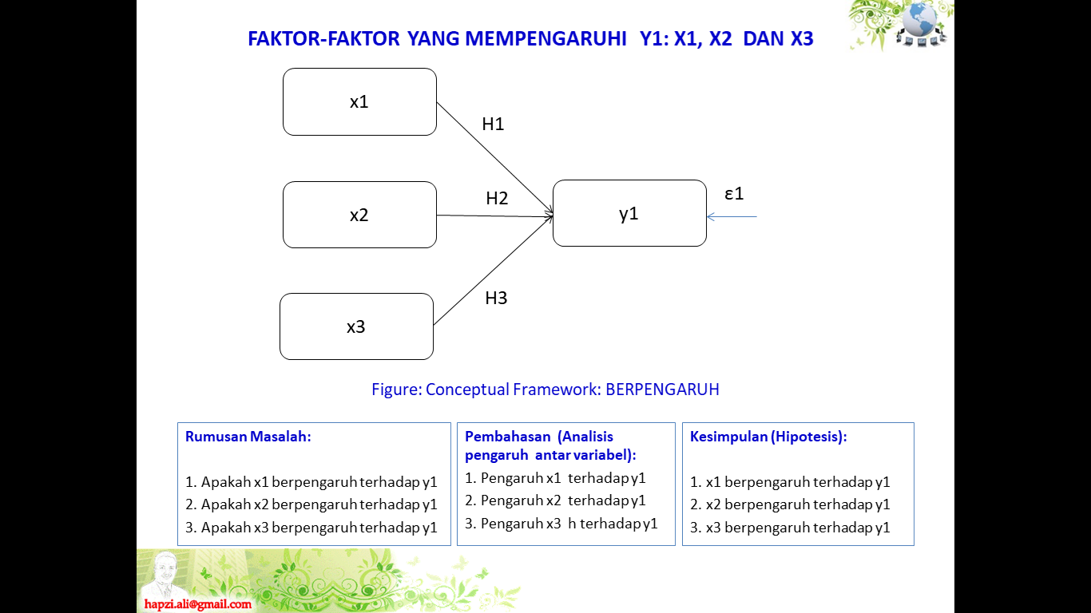

Source: Research Results ***(size 10, center)***

**Figure 1. Conceptual Framework** ***(size 10, bold, center)***

*enter 1 x*

**&&&**

**BLUE COLOR SECTIONS OR SUB MANUSCRIPTS**

The blue color is part or sub-chapter of the article manuscript) as shown in the image below

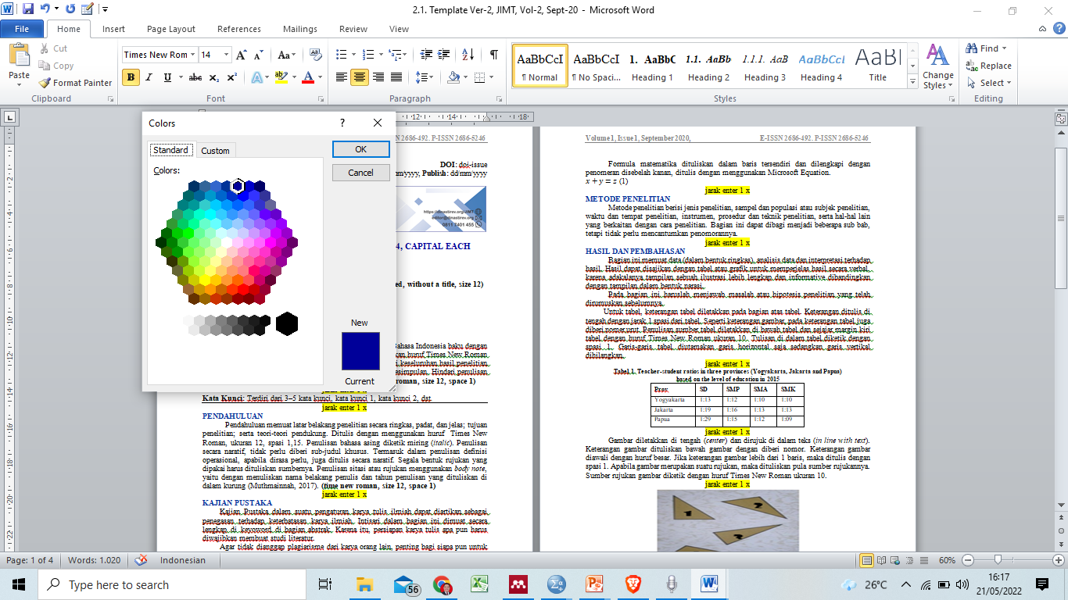

**FOOTER ATAU PENOMORAN HALAMAN MANUSCRIPT**

Footer and page numbering of manuscripts (articles) use: **Accent Bar 2**. The tutorial is (Inset🡺 Page Number🡺Bottom Page🡺Accent Bar 2.

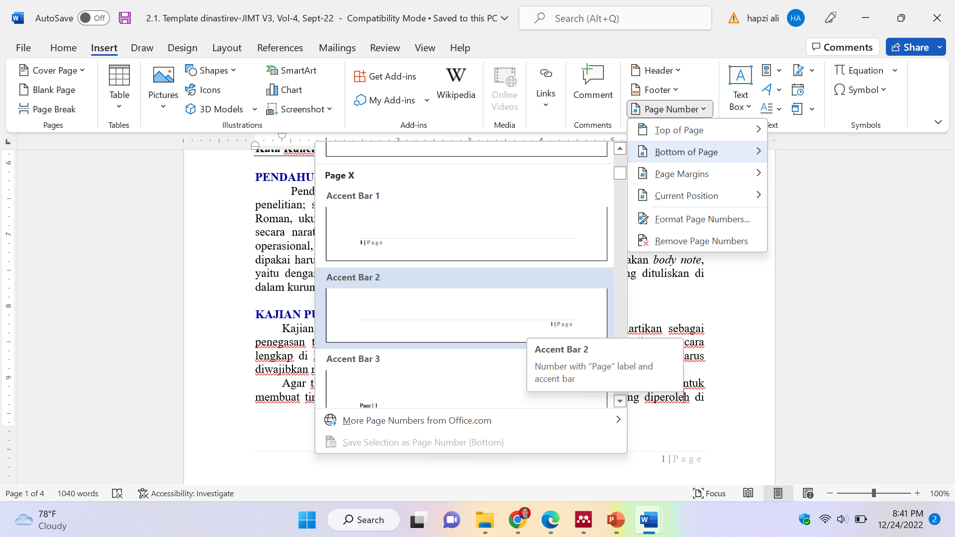

**NOTE**

# A4 paper

1. Standard margins (top-bottom-right-left= 2.54)
2. Black letter or text color
3. The color of the letters or text of the section or sub-chapter is blue, as shown in the example in this template and attached below.
4. 1 Space,
5. Font type time new romance,
6. Manuscript font size 12
7. Font size for table and figure titles 10
8. Font size contents of tables and figures 10
9. Header and footer font size 10
10. Spacing between paragraphs (spacing before and after) = 0
11. The distance between sub-chapters or sections 1 x enter
12. Number of pages 7-15 pages:
    1. **Abstract** and **Introduction** (maximum 25%),
    2. **Method** (maximum 15%),
    3. **Results and Discussion** (minimum 40%),
    4. **Conclusions and References** (maximum 20%).
13. Do not use numbering, apart from numbers 1,2,3, and so on other than the formulation of the problem, discussion, and conclusion. Example: 1. aaaaa; 2. bbbbb; 3. ccccc; etc.
14. If you use a number other than the formulation, discussion and conclusion, you must use a different number from the formulation, discussion and conclusion. Example: a). pppppp; b). qqqqq; c). rrrrr; etc.
15. References use the concept or style of the American Psychological Association (APA).
16. Explanations in yellow and these note are removed from the manuscript (article)
17. Manuscripts that do not conform to the format and template will be rejected
18. The contents of articles published in the International Journal of Psychology and Health Science (IJPHS) are outside the responsibility of the Publisher.
19. The article published on Greenation Publisher is the result of the author's team research and this title has never been published in another Journal
20. Minimum references are sourced from 20 international scientific journals and national journals.

**&&&**